How to assemble the flapping butterfly

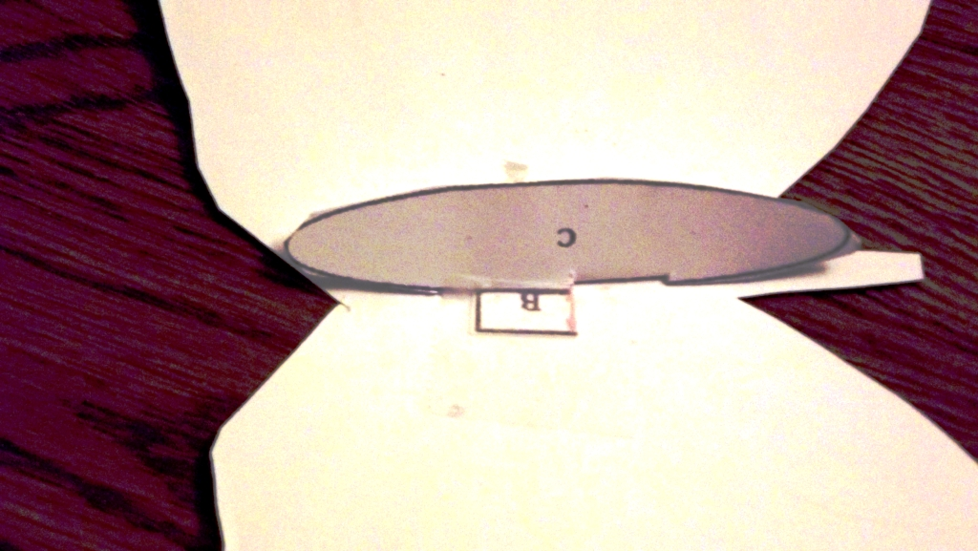
Tape tabs A and B to underside of the wings
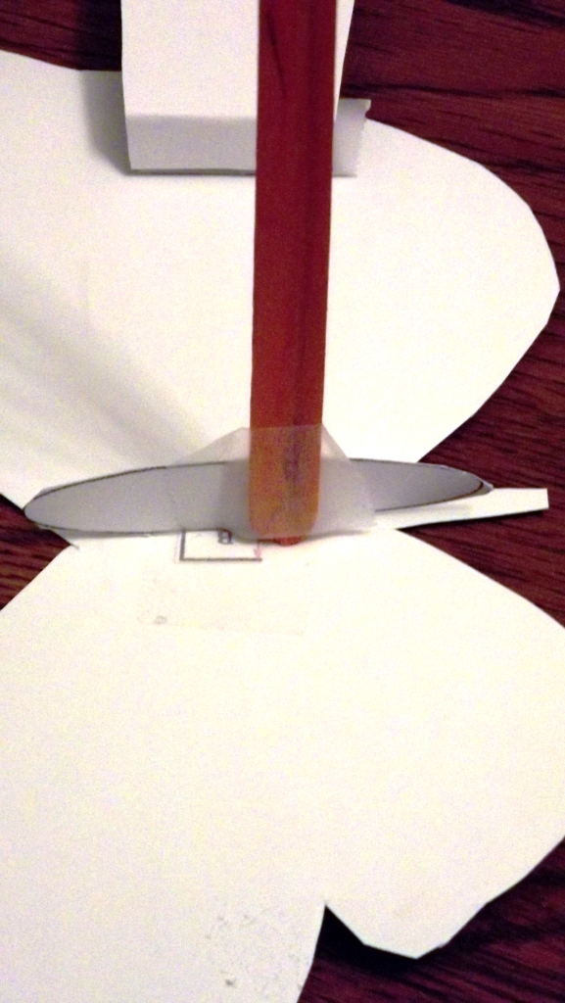
Tape end of craft stick to center of the abdomen
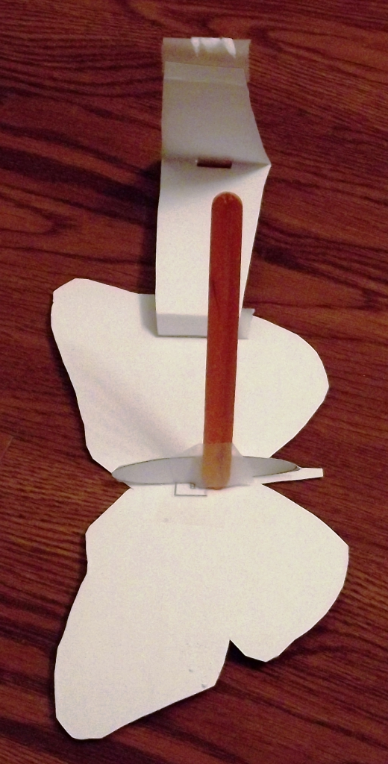
Tape one end of cloud pattern section to edge of wing
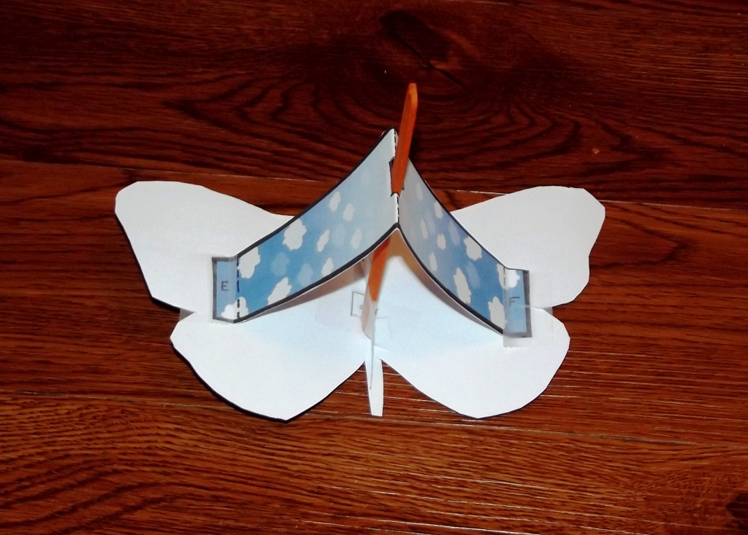
Place cut out slot in cloud pattern section over craft stick and tape the other end of the section to the opposite wing
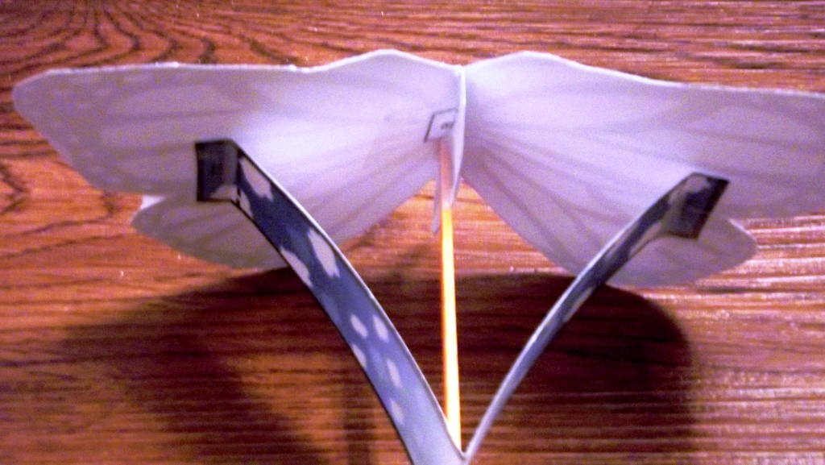
Once taped properly the underside should look like this
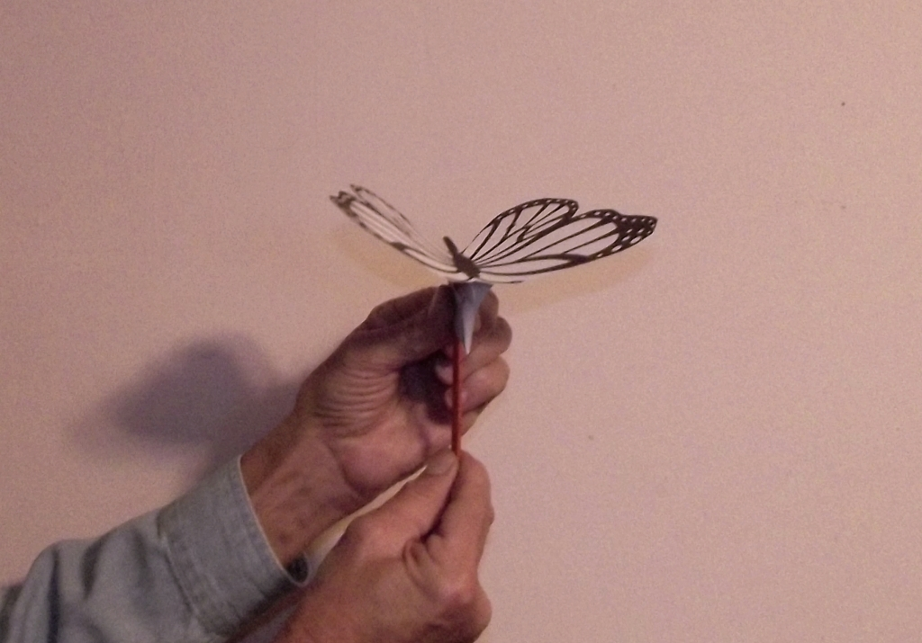
While holding cloud pattern section with one hand pull down on the craft stick with the other hand to make the wings flap upwards
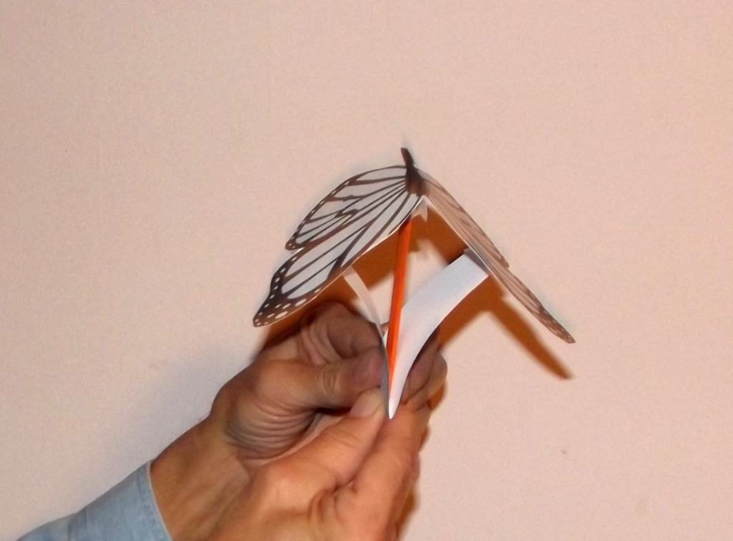
Push up on craft stick to make the wings flap downwards

